Project Title: Gig Compass

John LaTona

Lisa Zapson

Elisheva Elbaz

Christian Perry

Project Description:

Allow users to search for ticketmaster events within a regional area.

Events in the area will show up in list view and map view.

When an event from the list or the map is clicked on, a new page will open with more information about the event, and the ability to purchase tickets.

APIs:

Using the ticketmaster API to find music events taking place at the user input location.

Using Google Maps API to display the locations of these events on a map

Wireframe:

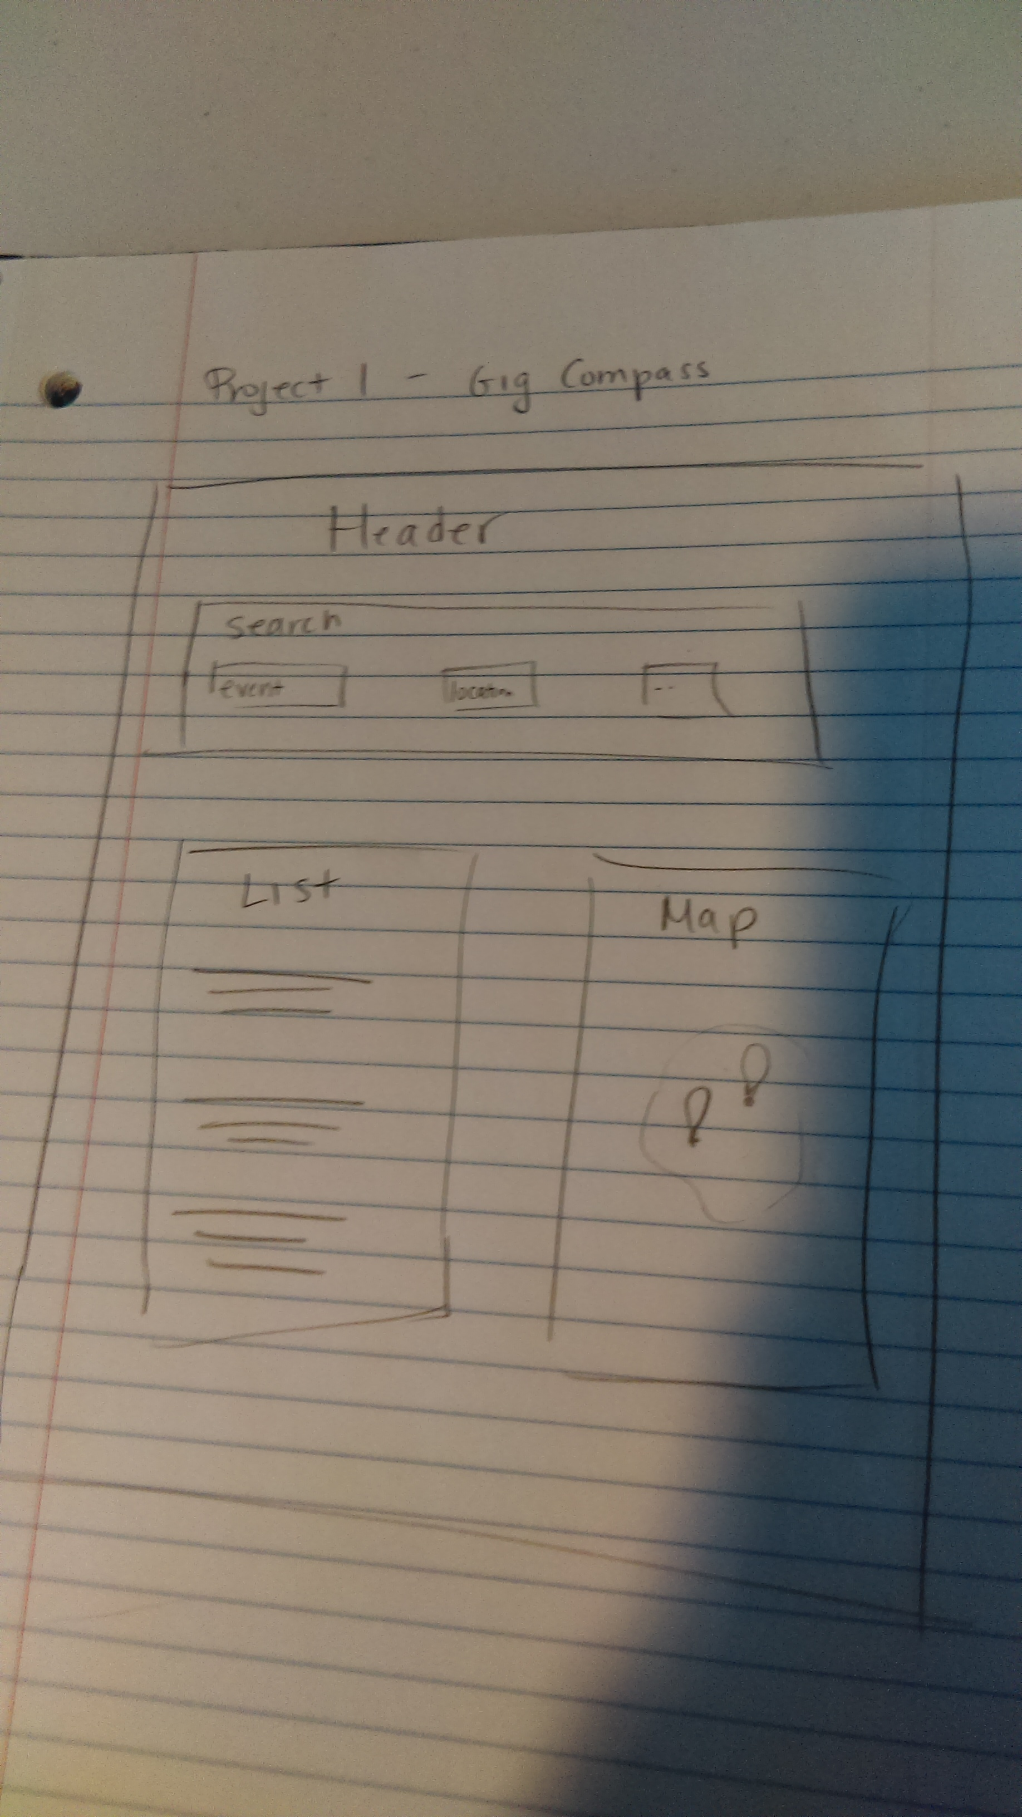

Tasks:

